Nutritional Analysis
Name:
Institution:
Date:

Intake food list and analysis |  |  |  |  |  |  |  |  |  |  | Daily Calorie Goal |  |  | 1569
 | Meal | Food / Drink | # of Servings |  | Serving  Size | Protein  (g) | Carbs  (g) | Sugar  (g) | Choleste-  rol(mg) | Saturated  fat (g) | Total  Fat  (g) | Dietary  fiber (g) | Sodium  (mg) | Calories
Wed, Apr 1, 2020 | B | Peanut Butter Sandwich | 1 |  | 1 | 12.23 | 42.2 | 5.45 | 0 | 3.48 | 16.89 | 3.3 | 568 | 342
Wed, Apr 1, 2020 |  | Egg (Large) |  |  | 1 | 6 | 0 | 0.2 | 70 | 1.5 | 4.8 | 0 | 70 | 70
Wed, Apr 1, 2020 |  | Coffee, no sugar |  |  | 8 oz | 0.28 | 0 | 0 | 0 | 0.01 | 0.05 | 0 | 5 | 2
Wed, Apr 1, 2020 | L | Cobb Salad w/ dressing | 1 |  | 1 | 33 | 22 | 9 | 190 | 12 | 28 | 6 | 1370 | 480
Wed, Apr 1, 2020 |  | Potato chips |  |  | 1 bag | 1.84 | 13.93 | 1.15 | 0 | 3.07 | 10.49 | 1.2 | 147 | 153
Wed, Apr 1, 2020 |  | Red table wine |  |  | 15 oz | 0.1 | 3.84 | 0.91 | 0 | 0 | 0 | 0 | 6 | 125
Wed, Apr 1, 2020 | D | Alaskan Salmon Burger | 1 |  | 1 | 18 | 0 | 0 | 50 | 1.5 | 7 | 0 | 320 | 140
Wed, Apr 1, 2020 |  | White rice |  |  | 1 cup cooked | 4.26 | 44.52 | 0.09 | 0 | 0.12 | 0.44 | 0.6 | 577 | 204
 | S | Fruit Gushers |  |  | 1 pouch | 0 | 20 | 12 | 0 | 0 | 1 | 0 | 45 | 90
 |  | water |  |  | 16 oz | 0 | 0 | 0 | 0 | 0 | 0 | 0 | 0 | 0
165 |  |  |  |  | DAILY TOTALS (Calories Remaining: 70) | 75.71 | 126.49 | 28.59 | 310 | 21.67 | 68.87 | 11.1 | 3108 | 1606

Chart: B = Breakfast, L = Lunch, D = Dinner, S = Snack
Source: Fatsecret (n.d)
Exercise | Time | Speed | Calories burned
Walking | 30 minutes | 3 mph | 107

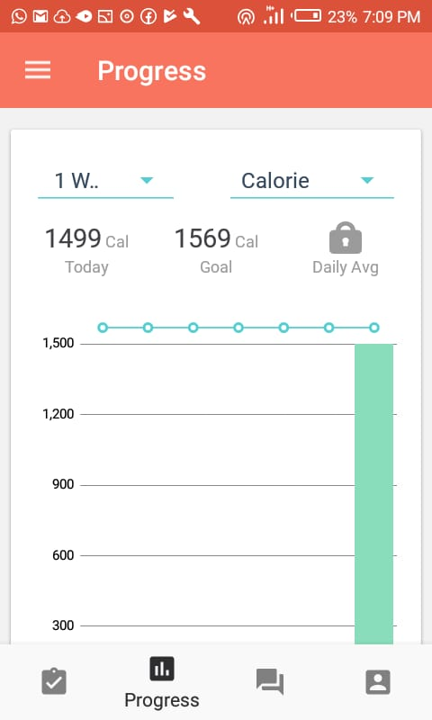
DRI graph

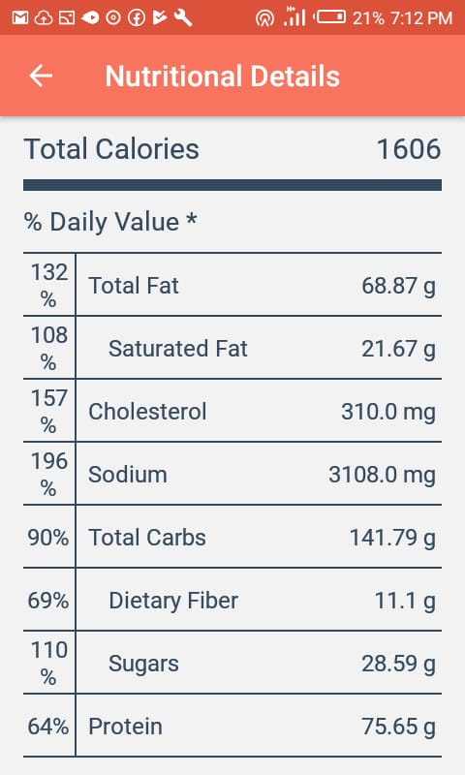
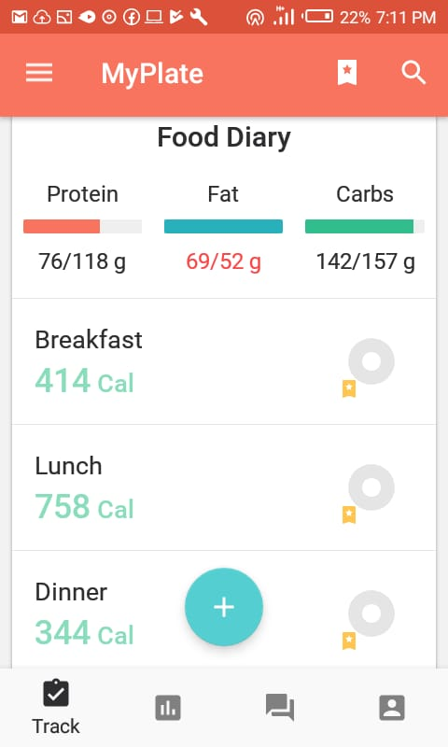
Calorie sources Fat sources

Nutritional analysis of the foods taken shows that cobb salad with dressing to be the highest source of proteins with 33 grams per meal. The peanut butter sandwich is also a substantial source with 12.23 grams as well as a salmon burger at 18 grams. Other important sources of the macronutrient include eggs, white rice, and potato chips. Despite the high intake of proteins, the summary reveals a protein deficit at 76/118 grams. This equals 64 percent of the preferred protein intake. It would be important to increase this intake to meet the daily target.
As for carbohydrates, white rice leads at 44.52 grams, followed by peanut butter at 42.2 grams and cobb salad at 22 grams. Potato chips and red table wine close the list of the top five carbohydrate sources. The summary indicates a sufficient intake of carbohydrates at 142/157 grams, which equals 90 percent of the set target. The daily deficit of 15 grams is within acceptable limits as indicated by the green color in the MyPlate app. Fats make the third category of macros. The analysis places cobb salad as the leading source at 28 grams. Peanut butter sandwich follows closely at 16.89 grams while potato chips close the top three at 10.49 grams. We find in the summary that this exceeds the allowable daily intake at 69/52 grams, translating to 132% fat intake. It would be prudent to reduce the intake of fats to achieve weight-loss goals.
Micronutrients, though required in fewer quantities, are equally essential for health. Some of the most important micros in the diet include sodium, cholesterol, and dietary fiber. The analysis shows cobb salad leading in the highest supplies of sodium at 1370 mg and 190 mg of cholesterol. Peanut butter sandwich and white rice are also substantial sources for sodium at 568 mg and 577 mg, respectfully. Alaskan salmon burger supplements 320 mg while potato chips close the list of top five at 147 mg. Of all the foods taken, only the peanut butter sandwich supplies substantial amounts of dietary fiber at 3.3 grams. Potato chips follow closely at 1.2 grams while white rice has 0.6 grams of fiber.
With doctors recommending cholesterol intake not exceeding 300 mg, the total 310 mg happens to be excessive. The summary from the MyPlate App indicates this to be equivalent to 157% intake thus necessitating a decrease of the same. According to the American Heart Association, the average daily intake of sodium should not exceed 2300 mg (Heart.org, n.d). That notwithstanding, the meals under analysis provide a whopping 3108 grams of sodium. This translates to 196 % as analyzed by the App. A reduction of sodium intake is inevitable if the weight loss goals are to be realized. Dietary fiber intake is below the allowable intake at 69 percent thus necessitating the increase of the same in the diet.
My choice of food is mainly influenced by American culture. For instance, data released in 2017 shows that coffee still dominates tea in America despite increasing consumption of the latter (Royal Cup, 2017). I would rather eat a salmon burger than beef products as these are associated with several health risks. I also like taking red wine during meals as it assists in digestion and also lowers the risk of heart disease. Red wine helps to maintain the right levels of good cholesterol. I use fruit gushers to supplement vitamin intake. Despite the controversy that surrounds the nutritional value of fruit gushers, I still prefer the drink due to the compelling marketing campaigns behind them.
According to the analysis by the MyPlate Calorie Counter app, several changes in diet are required to meet the target. The first would be to increase my protein intake while reducing the intake of sodium and cholesterol. An option is to increase protein intake during breakfast by taking foods such as turkey sausages and cheese burrito. Data shows that this food contains 18 grams of protein, which is way higher than that available in my current breakfast (Fatsecret, n.d). Healthy tuna lettuce wraps contain 16.26 grams of protein and make better dinner than white rice. To address the sodium and cholesterol problem, I would consider replacing cobb salad with a portion of healthier food.

References
Fatscecret (n.d). Browse common foods. Fatscecret. Retrieved on 2 April 2020, from https://www.fatsecret.com/calories-nutrition/
Heart.org (n.d) Why Should I Limit Sodium? Heart.org. Retrieved on 2 April 2020, from https://www.heart.org/-/media/data-import/downloadables/8/2/0/pe-abh-why-should-i-limit-sodium-ucm_300625.pdf
Royal Cup (2017, June 28) In the United States, Coffee Reigns Supreme, But Why? Retrieved on 2 April 2020 from http://www.royalcupcoffee.com/blog/articles/united-states-coffee-reigns-supreme-why

